**NATIONAL ACADEMY FOR LEARNING**

**CLASS PRACTICE WORKSHEET – ALTERNATING CURRENT**

1. The figure given shows the variation of an alternating emf with time. What is the average value of the emf for the shaded part of the graph?

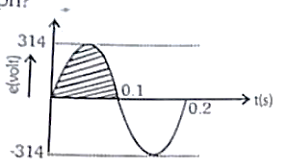

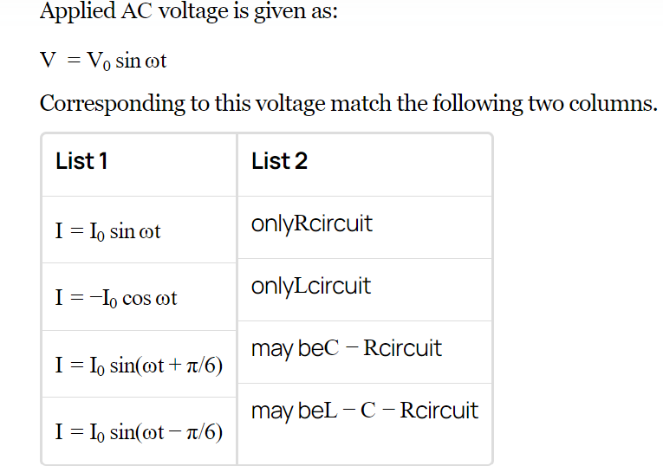

1. You are given many resistances, capacitors and inductors. These are connected to a variable DC voltage source (the first two circuits) or an AC voltage source of 50 Hz frequency (the next three circuits) in different ways as shown in Column II. When a current I (steady state for DC or rms for AC) flows through the circuit, the corresponding voltage V1 and V2. (indicated in circuits) are related as shown in Column I. Match the two.